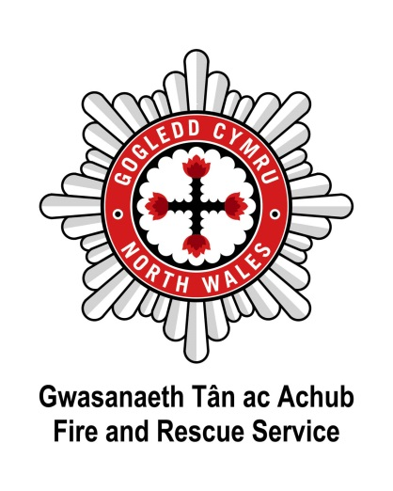

Dear Applicant

Thank you for requesting an application pack for this vacancy.

North Wales Fire and Rescue Service is an employer that is committed to equality of opportunity and welcomes applications from all sectors of the community who share our Core Values.

Please find enclosed the following:

* North Wales Fire and Rescue Service’s Core Values
* North Wales Fire and Rescue Service’s Welsh Language Scheme
* Guidance on completing your Application Form
* Application Form
* Equal Opportunities Monitoring Form
* Job Description and Person Specification

Should you require further information please do not hesitate to contact the Recruitment Team on 01745 535281 or email [hrdesk@nwales-fireservice.org.uk](mailto:hrdesk@nwales-fireservice.org.uk).

Please be advised that the Service is unable to issue correspondence in acknowledgment of applications, however, all applicants will be advised whether or not they have been selected for interview.

Please return completed Application Forms to the address below or via email to [hrdesk@nwales-fireservice.org.uk](mailto:hrdesk@nwales-fireservice.org.uk). Applications received after the closing date will not be considered.

Please do not submit your CV with your Application Form, as only the information provided within the Application Form will be used at the interview shortlisting stage.

Applicants should be aware that social networking websites are a public forum, particularly if the applicant is part of a "network". Applicants should not assume that their entries on any website will remain private. Any messages, posts or pictures found that are deemed abusive, defamatory or in conflict with our Core Values will result in applications being withdrawn from the recruitment process.

Thank you for the interest you have shown in joining North Wales Fire and Rescue Service.

Yours sincerely

**The Recruitment Team**

**North Wales Fire and Rescue Service**

The Recruitment Team

Human Resources

North Wales Fire and Rescue Service Headquarters

Ffordd Salesbury

St Asaph Business Park

St Asaph

LL17 0JJ

DenbighshireLL17 0JJ



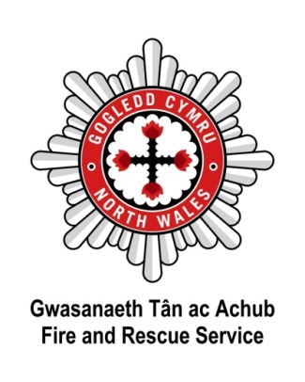****

**North Wales Fire and Rescue Service Welsh Language Scheme**

At North Wales Fire and Rescue Service, we pride ourselves on having taken the issue of the Welsh language seriously over many years. By acknowledging our moral and legal duties to protect the cultural heritage of the area and to meet the expectations of the local community, we also acknowledge the positive service benefits of conducting our public business in both languages. Saving lives and reducing risk are at the heart of our mission - the language issue is vital to its success.

In accordance with statutory requirements, North Wales Fire and Rescue Service developed a Linguistic Skills Strategy to provide a means of responding appropriately to the Service's commitments contained in the [Welsh Language Scheme.](http://www.nwales-fireservice.org.uk/media/52210/welsh_language_scheme_-_approved_feb_2010_english.pdf)

As part of this Strategy, North Wales Fire and Rescue Service introduced the requirement for all new members of staff to have the ability to show basic Welsh language courtesy skills to at least Level 2. All new staff are allowed a specified period of time after formal appointment to achieve Level 2 standard.

Please note that Level 2 is the **minimum requirement** and that the assigned Welsh Language level for each post is listed in the **Person Specification**.

The Level 2 Assessment involves a 15 minute verbal test - assistance is provided beforehand in the form of a training CD and accompanying script, as well as further help and support which is available from our Welsh Language Champions. We are committed to supporting individuals as far as we can to attain the required level.

Applicants who already possess Welsh language skills or who are applying for posts with a Welsh Language requirement higher than Level 2 will be assessed against higher levels.

The demonstration of linguistic skills is also considered in the process of seeking promotion within North Wales Fire and Rescue Service.

For further information, please visit our website:

[www.nwales-fireservice.org.uk/equality,-diversity-and-welsh-language-policy/welsh-language-policy.aspx?lang=en](http://www.nwales-fireservice.org.uk/equality,-diversity-and-welsh-language-policy/welsh-language-policy.aspx?lang=en)

North Wales Fire and Rescue Service welcomes communication in Welsh and English equally, and will respond without delay to correspondence or calls in both languages.

Please note which language you would prefer to receive communication in from North Wales Fire and Rescue Service: Welsh  English  Bilingual

Should you be shortlisted for interview, in which language would you prefer the interview to be conducted? Welsh  English

If you would like to change your preference at any point please email:

[hrdesk@nwales-fireservice.org.uk](mailto:hrdesk@nwales-fireservice.org.uk).

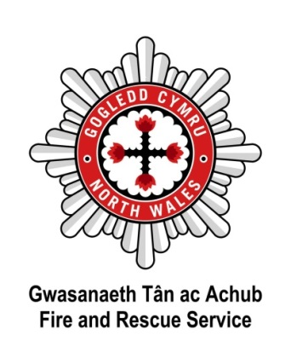

**Guidance on completing your Application Form**

1. Please complete all sections of the Application Form in as much detail as possible, if a section does not apply to you, please write N/A (not applicable) in the space provided.
2. Use block capitals and black ink when writing or type your application with a minimum font size of 11.
3. If driving is a requirement of the post (as noted in the Person Specification), you will be required to provide a unique licence check code if you are shortlisted for interview. Visit <https://www.gov.uk/view-driving-licence> for more information on this.
4. Only applicants who meet all of the Essential Criteria (as noted in the Person Specification) will be shortlisted for interview, Desirable Criteria may be referred to in the event there are significant applicants for a vacancy. Statements of fact and or inferences can not be accepted as evidence at the shortlisting stage, therefore, please provide clear examples of relevant evidence, for example;

***Essential Criteria****: Knowledge and understanding of Microsoft Office Applications.*

***Acceptable:*** *In my current role I am required to produce reports for the organisation on monthly expenditure. I utilise Microsoft Access to provide statistical information with the necessary formulae to calculate the subtotals and totals for each month and year end. I then present the information in a report to the Board using Microsoft Word using both text and graphs to display the numerical information.*

***Not Acceptable:*** *I have knowledge and understanding of Microsoft Office applications.*

1. Ensure your application details why you are interested in the role and what skills and experience you can bring to the role. Skills and experience gained through employment, voluntary work or social and domestic situations are all valid. CVs attached to Application Forms will not be read or considered at the shortlisting stage.
2. In line with the Service’s Core Values and in compliance with the Rehabilitation of

Offenders Act 1974 and the Safeguarding Vulnerable Groups Act 2006, the Service does not require you to disclose details of any ‘spent’ convictions, unless however, the post you are applying for involves working with vulnerable adults or children – then you must disclose all convictions, cautions, reprimands or final warnings.

All posts involving regular contact with vulnerable groups will be subject to an Enhanced Criminal Records Disclosure (unspent and spent convictions disclosed) and all other posts will require a Basic level Criminal Records Disclosure (only unspent convictions disclosed).

The Person Specification advises whether an Enhanced or Basic level Criminal Records Disclosure is required for the particular post.

To confirm if a conviction is ‘spent’ or ‘unspent’ visit [www.disclosurecalculator.org.uk](http://www.disclosurecalculator.org.uk/).

1. Ensure your Application Form is returned by noon of the closing date – late applications cannot be considered.

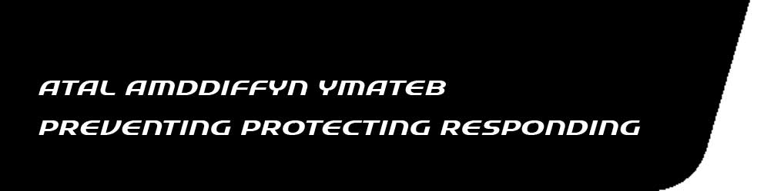 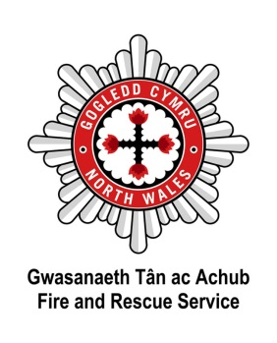

|  |
| --- |
| **APPLICATION FORM – STRICTLY CONFIDENTIAL Please complete in black ink or type** |

|  |  |
| --- | --- |
| Application for the post of:  **HR Management Assistant** | Closing Date:  **noon 25.03.2019** |
| Surname: | Forenames(s): |
| Address: | |
| Post Code: | Tel Home No: |
| Mobile No: | Tel No Work: |
| National Insurance No: | Email Address: |
| Do you hold a current UK driving licence? Yes  No | What type of licence? |
| **If you are successfully shortlisted for interview, and driving is a requirement of the post as indicated on the Person Specification, you will be required to provide a unique licence check code - failure to do so may result in your application failing to progress.** | |

|  |  |  |  |  |  |
| --- | --- | --- | --- | --- | --- |
| **CURRENT / MOST RECENT POST** | | | | | |
|  | | | | | |
| Name & Address of Employer | Position Held | Salary/Grade | Date Started | Period of Notice | Reason for Leaving |
|  |  |  |  |  |  |
|  |  |  |  |  |  |
| Please give brief details of your present duties/responsibilities: | | | | | |

|  |  |  |  |  |  |
| --- | --- | --- | --- | --- | --- |
| **PREVIOUS EMPLOYMENT** (**Please include any periods of unemployment**) | | | | | |
|  | | | | | |
| Name & Address of Employer | Position Held | Salary | Date Started | Date To | Reason for Leaving |
|  |  |  |  |  |  |

|  |
| --- |
| **EDUCATIONAL AND OTHER QUALIFICATIONS** (**Schools/Colleges/University etc**) |

|  |  |  |  |
| --- | --- | --- | --- |
| Name of School, College, University or Education /Training Centre | Subjects | Qualification/Examination Result | Awarding Body |
|  |  |  |  |

|  |
| --- |
| **CURRENT MEMBERSHIP OF PROFESSIONAL INSTITUTES/BODIES** |

|  |  |
| --- | --- |
| Name of Institute | Grade / Level of Membership |
|  |  |

|  |
| --- |
| **EXPERIENCES/ACHIEVEMENTS** |

|  |
| --- |
| Please give details of your knowledge, skills and experience which you feel are relevant to the requirements of this post and your application. (Please attach a continuation sheet if required). **It is essential that the application demonstrates that you are able to satisfy the essential requirements of the post, as detailed in the person specification - failure to do so may result in your application failing to progress.** |

|  |
| --- |
| **REHABILITATION OF OFFENDERS ACT 1974 and SAFEGUARDING VULNERABLE GROUPS ACT 2006** |

|  |  |
| --- | --- |
| Under the provisions of these Acts and Regulations you need not normally disclose details of any ‘spent’ convictions. However, if the post you are applying for involves regulated activity with vulnerable adults or children then you must disclose all convictions, cautions, reprimands or final warnings, as if your application is successful you will be subject to an Enhanced DBS Check. All other posts will require a Basic Level DBS Check. By signing this application form you are hereby giving consent to undertake the above checks if your application is successful. The Person Specification will advise if the post you are applying to requires an Enhanced or Basic Level DBS Check. | |
| Do you have any ‘unspent’ convictions? | Yes  No |
| (If Yes, please give details of the offence date and the sanction imposed) | |
| *Please only answer the following question if the post you are applying to will be subject to an Enhanced DBS Check.* Do you have any ‘spent’ convictions, cautions, reprimands or final warnings? | Yes  No |
| (If Yes, please give details of the offence date and the sanction imposed) | |

|  |
| --- |
| **INTERESTS (CLUBS, SOCIETIES, SPORTS, GAMES, HOBBIES ETC)** |

|  |
| --- |
|  |

|  |
| --- |
| **KNOWLEDGE OF LANGUAGES** – **Please tick where appropriate** |

|  |  |
| --- | --- |
| Are you able to speak Welsh to the standard outlined within the person specification?  Are you able to speak English to the standard outlined within the person specification? | Yes  No  Yes  No |
| Are you able to read/write in Welsh to the standard outlined within the person specification?  Are you able to read/write in English to the standard outlined within the person specification? | Yes  No  Yes  No |

|  |
| --- |
| **ADDITIONAL INFORMATION** |

|  |
| --- |
| Are you personally connected to any employee of North Wales Fire & Rescue Service (examples of a personal connection include, but are not limited to, relatives, partners or friends and people you communicate with outside of employment either face to face, over the phone, or online). If so, please provide details below – please attach another sheet if required. |
| Name:  In what capacity are they known to you:  Have you discussed this application with them? Yes  No |

|  |
| --- |
| Please give any dates in the near future when you will not be available for interview. |
|  |

|  |
| --- |
| **REFERENCES** |

|  |  |  |  |  |
| --- | --- | --- | --- | --- |
| Please give the name and address of two referees, one of which should be your current employer (note we will not contact current employers unless you have been offered a position with North Wales Fire & Rescue Service.) I hereby authorise you to take up references from my previous employer(s), my present employer (once the offer of employment has been confirmed in writing) and any personal referees. In addition, I hereby authorise you to take up other reference checks as you may deem appropriate. | | | | |
| Name & Address | How long and in what capacity has the referee known you | | | |
|  |  | | | |
|  |  | | | |
| **Have you recently received an exit**  **payment from another public body?** | **Yes** |  | **Date payment received:** |  |
| **No** |  |

|  |
| --- |
| **DECLARATION** |

|  |  |
| --- | --- |
| Canvassing by an applicant of members of the Fire & Rescue Authority either directly or indirectly shall disqualify the candidate concerned for the appointment. | |
| I declare that the statements given on this form are true and accurate to the best of my knowledge and belief and I am not aware of any circumstances, which if known, or become known, to the Fire & Rescue Authority might cause them to question my suitability for appointment. | |
| Signed:  Forms received via email will not require a wet signature. | Date: |

|  |
| --- |
| Where did you see the advertisement? |

Thank you for taking the time to complete this application.

Please return completed Application Forms to the address below or via email to

[hrdesk@nwales-fireservice.org.uk](mailto:hrdesk@nwales-fireservice.org.uk).

Please do not submit your CV with your Application Form, as only the information provided within the Application Form will be used at the shortlisting stage.

Applications received after the closing date will not be considered.

The Recruitment Team

Human Resources

North Wales Fire and Rescue Service Headquarters

Ffordd Salesbury

St Asaph Business Park

St Asaph

Denbighshire

LL17 0JJ

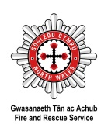

***For the attention of HR: To be detached from application form upon receipt***

**Equalities Monitoring**

|  |  |  |  |  |  |  |  |  |  |  |
| --- | --- | --- | --- | --- | --- | --- | --- | --- | --- | --- |
| **Name:** | |  | | | | | | | **Date of Birth:** | |
| **Date completed:** | | |  | | | | | | | |
| **Post Applied For:** | | |  | | | | | | | |
| **Fire Service Number: *(Internal Application only)*** | | | | | |  | | | | |
| As a public authority North Wales Fire and Rescue Service is required to take steps and aims to promote equality of opportunity and combat discrimination. This information does not form any part of your application and is removed from your application form before submission to the short-listing stage. The information gathered will be used for monitoring, and informing positive action initiatives. | | | | | | | | | | |
|  | | | | | | | | | | |
| **Ethnicity *What is your ethnic group?*** | | | | | | | | | | |
|  | | | | | | | | | | |
| **White** | | | | |  | | **Mixed/multiple ethnic groups** | | | |
|  | British | | | |  | |  | White and Black Caribbean | | |
|  | Welsh | | | |  | |  | White and Black African | | |
|  | English | | | |  | |  | White and Asian | | |
|  | Scottish | | | |  | |  | Do not wish to state | | |
|  | Irish/Northern Irish | | | |  | |  | Other please specify below: | | |
|  | Gypsy or Irish Traveller | | | |  | |  |  | | |
|  | Do not wish to state | | | |  | | | | | |
|  | Other please specify below: | | | |  | | **Asian/Asian British** | | | |
|  |  | | | |  | |  | Indian | | |
|  | | | | |  | |  | Pakistani | | |
| **Black/African/Caribbean/Black British** | | | | |  | |  | Bangladeshi | | |
|  | African | | | |  | |  | Chinese | | |
|  | Caribbean | | | |  | |  | Do not wish to state | | |
|  | Do not wish to state | | | |  | |  | Other please specify below: | | |
|  | Other please specify below: | | | |  | |  |  | | |
|  |  | | | |  | | | | | |
|  |  | | |  |  | | **Any other Ethnic Group** | | | |
|  |  | | | |  | |  | Other please specify below: | | |
|  |  | | | |  | |  |  | | |
|  | | | | | | | | | | |
| **Sex and Sexual Identity:** | | | | | | | | | | |
|  | | | | | | | | | | |
| **Sex: What is your sex?** | | | | |  | | **Sexual Identity: which best describes how you think of yourself?** | | | |
|  | Female | | | |  | |  | Heterosexual/Straight | | |
|  | Male | | | |  | |  | Gay/Lesbian | | |
|  | | | | |  | |  | Bisexual | | |
| **Gender Identity: Which of the following describes how you think of yourself?** | | | | |  | |  | Do not wish to state | | |
|  | Female | | | |  | |  | Other please specify below: | | |
|  | Male | | | |  | |  |  | | |
|  | In another way | | | |  | |  |  | |  |
|  | Not applicable | | | |  | |  |  | |  |
|  | Do not wish to state | | | |  | |  |  | |  |

|  |  |  |  |  |  |  |  |  |
| --- | --- | --- | --- | --- | --- | --- | --- | --- |
| **Disability and Marriage or Civil Partnership** | | | | | | | | |
|  | | | | | | | | |
| **Disability**  North Wales Fire and Rescue Service operate an Interview Guarantee Scheme for candidates with disabilities (Two Ticks). This means that any job applicant, who has a disability and meeting the essential job requirement set out in the person specification, will be invited to the selection process/interview. A disability is defined under the Equality Act 2010 as a physical or mental impairment, which has a substantial long-term adverse impact on a person’s ability to carry out normal day-to-day activities.  **Marriage or Civil Partnership Same Sex Couples**  Civil partnerships in the United Kingdom, granted under the Civil Partnership Act 2004, allow same-sex couples to obtain essentially the same rights and responsibilities as civil marriage.  The Marriage (Same Sex Couples) Act 2013 legalised full same-sex marriage starting from March 2014, although civil partnership also remains available. | | | | | | | | |
|  | | | | | | | | |
| **Disability** | | |  | **Marriage or Civil Partnership** | | | | |
| *Do you have a long-standing physical or mental health condition or disability? By long standing, we mean anything that has lasted or is likely to last at least 12 months.* | | | What is your legal marital or same-sex status? | | **Opposite Sex** | **Same Sex** | |
|  | Physical Impairment | | Married | |  |  | |
|  | Sensory Impairment | | Living with a partner | |  |  | |
|  | Mental Health condition | | Registered Civil Partnership | |  |  | |
|  | Long standing illness or health condition | |
| Single | | | |  |
|  | Other such as disfigurement | | Widowed | | | |  |
|  | Learning Disability | | Separated | | | |  |
|  | Do not wish to state | | Divorced | | | |  |
|  | None | |  | Do not wish to state | | | |  |
|  | | | | | | | | |
|  | | | | | | | | |
| **National Identity and Religion** | | | | | | | | |
|  | | | | | | | | |
| **National Identity:** | | |  | **Religion: What is your religion?** | | | | |
|  | British | |  |  | No Religion | | | |
|  | Welsh | |  |  | Christian (All denominations) | | | |
|  | Scottish | |  |  | Buddhist | | | |
|  | English | |  |  | Hindu | | | |
|  | Irish/Northern Irish | |  |  | Jewish | | | |
|  | Do not wish to state | |  |  | Sikh | | | |
|  | Other please specify below: | |  |  | Muslim | | | |
|  |  | |  |  | Do not wish to state | | | |
|  |  |  |  |  | Other please specify below: | | | |
|  |  | |  |  |  | | | |

|  |  |
| --- | --- |
| *Official Use Only*: | |
| Date entered on Workforce |  |

|  |  |  |  |
| --- | --- | --- | --- |
| **Welsh language status:** | | | |
| Fluent | Learning | Attending Lessons | Cannot speak Welsh at all |