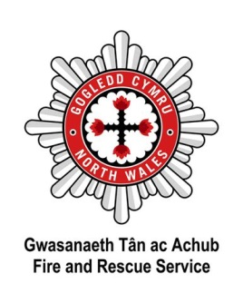
Gwasanaeth Tân ac Achub Gogledd Cymru
Ffurflen Atgyfeirio Prosiect Ffenics (B)

Manylion yr Asiantaeth Atgyfeirio:
Asiantaeth/ Ysgol |  |  |  | Enw cyswllt
 |  |  |  | Argyfwng
E-bost
Cyfeiriad
 |  |  |  |  |  | Cod Post
Manylion y myfyrwyr:
Enw Llawn |  |  | Anghenion addysg arbennig/ cymorth ychwanegol |  | Rheswm dros gyfeirio/ Unrhyw wybodaeth berthnasol (gan gynnwys problemau/anawsterau cymdeithasol, ymddygiadol, emosiynol, neu bryder cynnau tanau bwriadol) |  |  |  | Cofnod troseddol?
1
2
3
4
5
6
7
8
9
10
11
12
13
14
13
14
Rhaid cwblhau’r ffurflen hon yn llawn, ynghyd â’r ffurflen caniatâd rhiant/gwarcheidwad, cyn dyddiad cychwyn y cwrs- a chydymffurfio gyda gofynion y memorandwm cyd-ddealltwriaeth.
North Wales Fire and Rescue Service
Agency Referral Form (B)

Referral Agency details:
Agency/ School |  |  |  | Contact Name
 |  |  |  | Emergency
E-mail
Address
 |  |  |  |  |  | Post Code
Student details:
Full name |  |  | SEN / Additional support |  | Reason for referral / Other relevant information  (please include any social, emotional or behavioural difficulties, fire setting concerns) |  |  |  | Police record, tick if known?
1
2
3
4
5
6
7
8
9
10
11
12
13
14
13
14
This form, along with the Parent/ Guardian Consent form must be completed in full and returned prior to the start of the course – and comply with the requirements of the Memorandum of Understanding.

